

CSE422
ARTIFICIAL INTELLIGENCE
GROUP PROJECT
AI Based Multi Class Classification System for Predicting Obesity Levels
Group Number
16
Group Members
Syed Momtahin Mahmood, 21101188 Nabil Nashit, 21201060
Section: 07
Notebook: Google Colab

INTRODUCTION

The project aims to build a machine learning-based system that classifies individuals into obesity categories using the Obesity Levels dataset, based on their demographic and lifestyle attributes. The goal is to predict obesity types using features like eating habits, physical activity, and family history. The motivation stems from rising global obesity rates and the need for early prediction and prevention strategies.

METHODOLOGY

1. Dataset Description
Dataset name: Obesity
Number of Features: 17 columns; 1 target (NObeyesdad), 16 features
Type of Problem: Classification, because the target column (NObeyesdad) contains multiple categorical classes (e.g., Obesity_Type_I, Normal_Weight, etc.)
Data Points: Approximately 2,111 rows.
Types of Features: Both quantitative (e.g., Age, Weight, Height) and categorical (e.g., Gender, SMOKE, MTRANS).
Correlation: Seaborn heatmap used to visualize the correlation of all the features.

Correlation matrix:
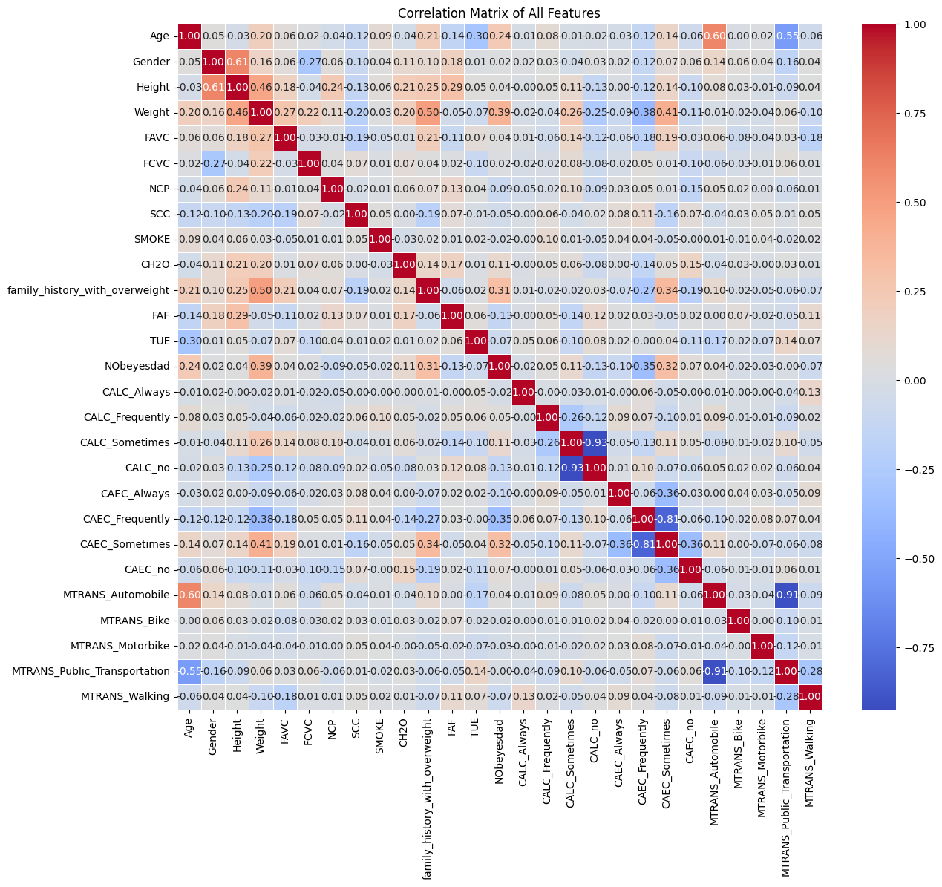

2. Pre-processing Techniques applied:

1. Import necessary libraries and data
2. Explore the data
3. Visualize the data
4. Handle missing values in features by filling with Mean, Mode
5. Encoding Features by Binary Encoding, One-Hot Encoding, Label Encoding
6. Show correlation between features
7. Feature Scaling (MinMax Scaler, Standard Scaler)
8. Feature selection
9. Split the data for training
10. Train models
11. Evaluate models by -
Accuracy, Precision, Recall, F1-Score, Confusion Matrix, ROC/AUC

3. Dataset Pre-processing

Problem 1: Missing Values
Found in: Gender, CH2O, family_history_with_overweight.
Solution: Imputed categorical ones with mode.

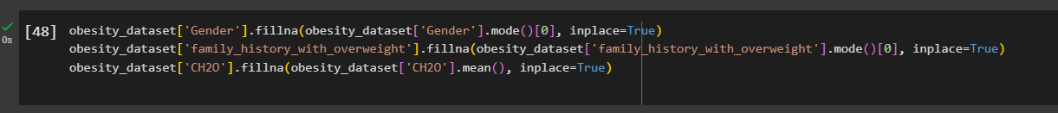Problem 2: Categorical Features
Categorical columns encoded using LabelEncoder or pd.get_dummies.

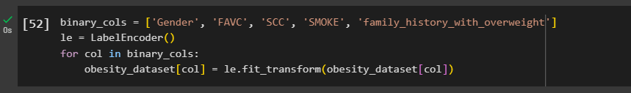
Problem 3: Feature Scaling
Scaled numerical features using StandardScaler.
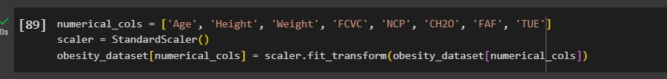

4. Dataset Splitting

Method: Stratified Split (because target is categorical and imbalanced)
Split Ratio: 70% training, 30% testing

5. Model Training & Testing

We applied:

- Logistic Regression
- KNN
- Decision Tree
- Neural Network (MLPClassifier)

5. Model Selection / Comparison Analysis

Bar chart showcasing Prediction Accuracy of all models:

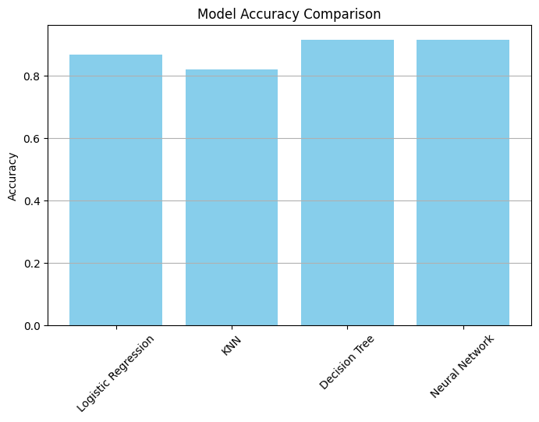

Precision, recall comparison of each model:
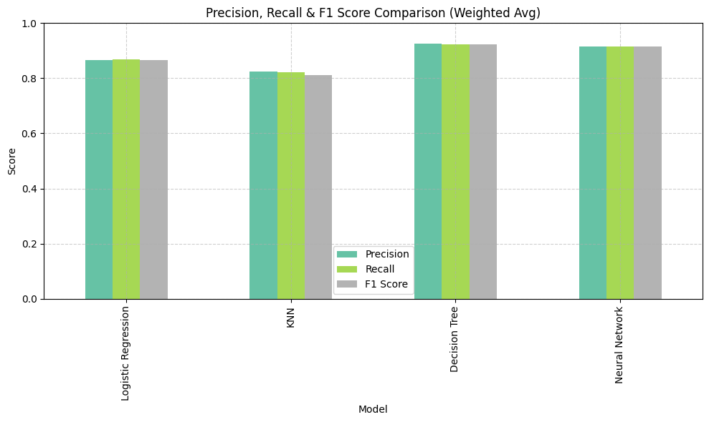

Confusion Matrix:

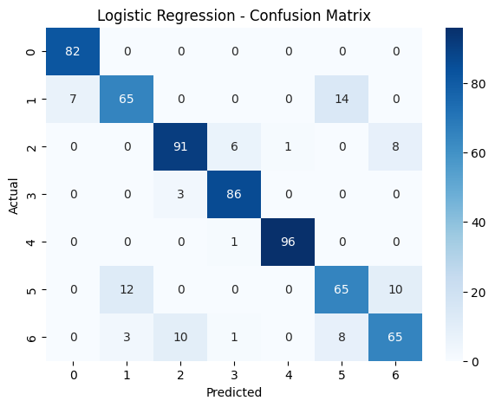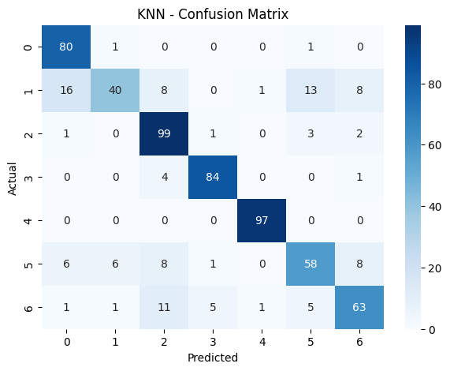

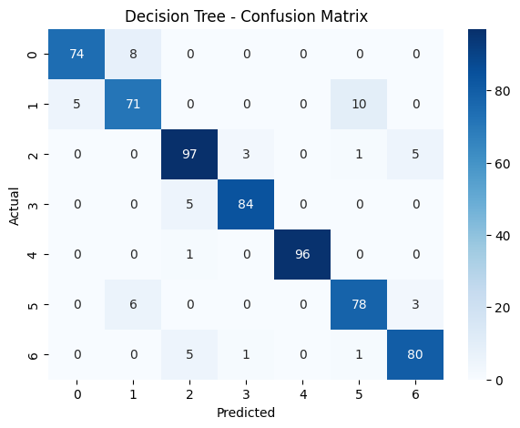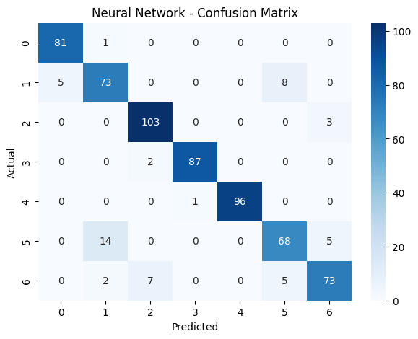

AUC score, ROC curve:

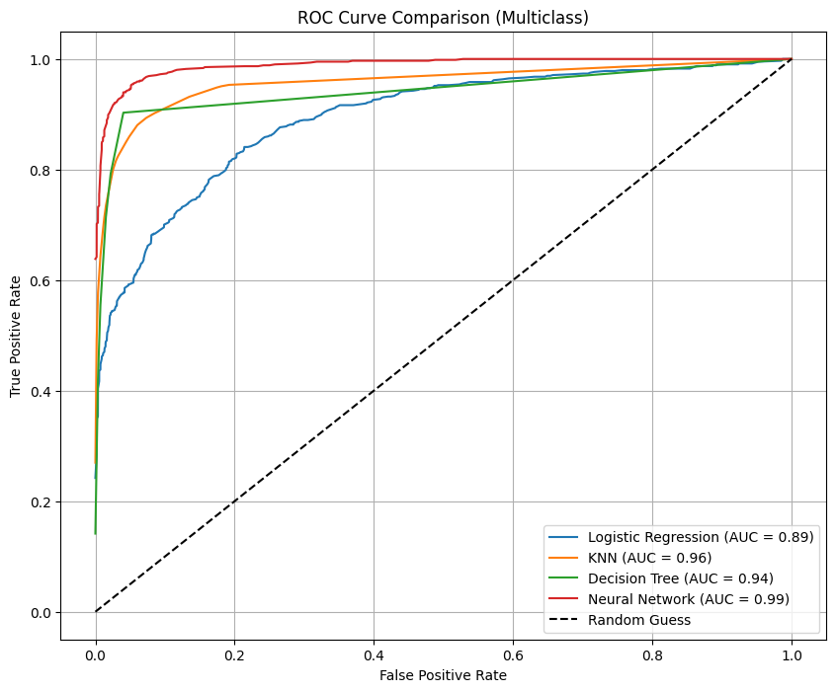

RESULT

After testing all our models, we found that Decision Tree and Neural Network performed the best when it came to predicting obesity levels. The Neural Network had the highest AUC score (0.9884), meaning it was great at separating the different categories. The Decision Tree, on the other hand, had the highest precision and F1 score, showing it was very accurate overall.
Logistic Regression gave solid, consistent results and proved to be a reliable baseline model. KNN was a bit behind in precision and recall but surprisingly had a high AUC (0.9574), meaning it still did a decent job in terms of classification.
These results make sense because models like Decision Trees and Neural Networks can handle complex patterns and relationships in the data better than simpler models.

The dataset had multiple classes and was a bit imbalanced, which made things harder for models like Logistic Regression and KNN. More complex models like Decision Trees and Neural Networks could handle this better because they can learn non-linear patterns. Data preprocessing (like scaling, encoding, and binarizing labels) really helped boost model performance, especially for the Neural Network.

Dealing with multiple obesity categories meant extra work for evaluation (e.g., binarizing labels and computing averaged metrics). Class imbalance affected some model results. We had to carefully explore and manage feature correlations. Plotting ROC curves for multiclass models was tricky and needed special handling using One-vs-Rest logic.

Overall, the project highlights the importance of model selection, data preprocessing, and evaluation metrics in building robust machine learning solutions. For this classification task, Decision Tree and Neural Network models stood out as the most effective, demonstrating the ability of tree-based and deep learning models to handle structured health data with multiple class labels.

